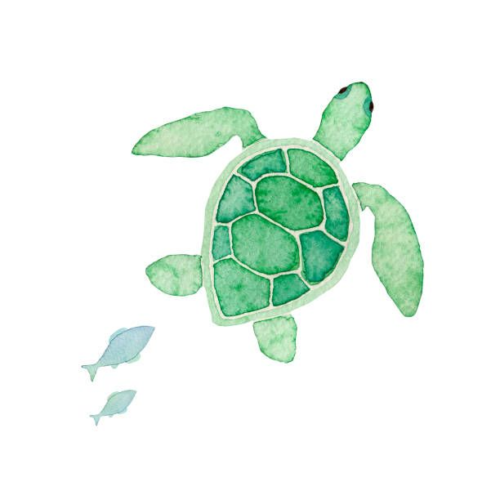

Python Level 1

HomeWorks

Genius Smart Education | Python Level 1 | 2025-2-4

Week (1) Homework

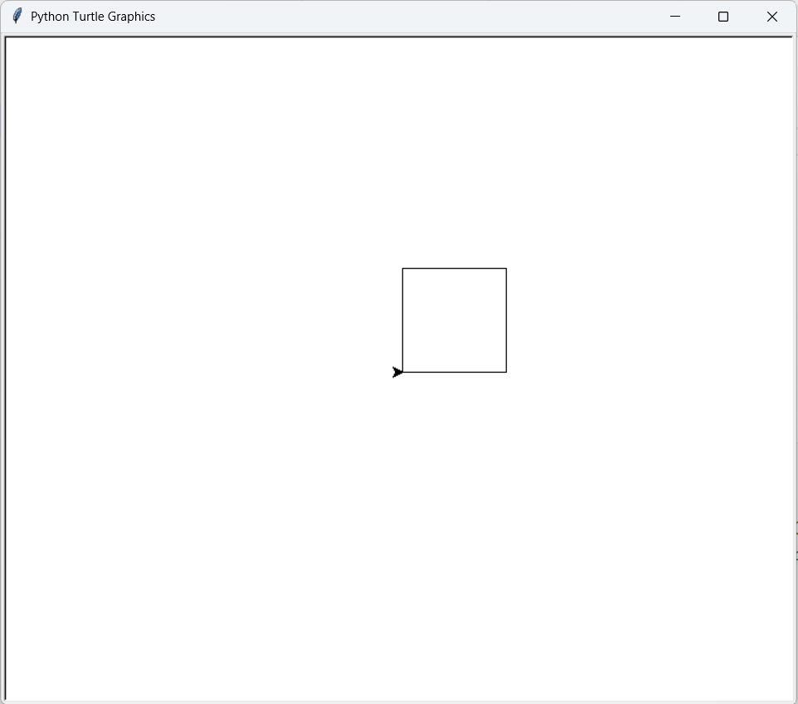

Week 1

Draw any Shape

Genius Smart Education | Python Level 1 | 2025-2-4

Week (2) Homework

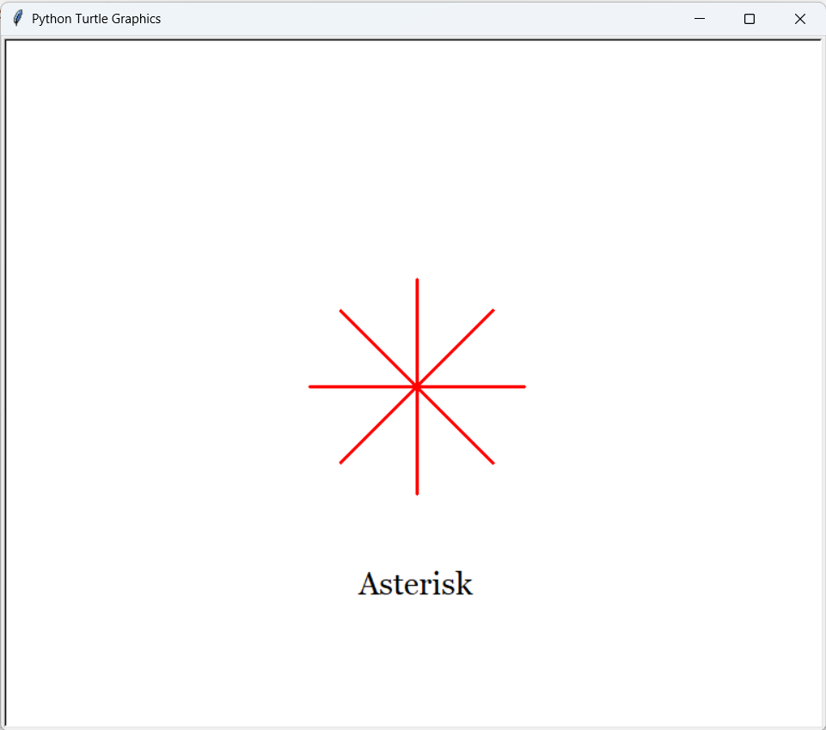

Week 2

draw Astrisk sign

Genius Smart Education | Python Level 1 | 2025-2-4

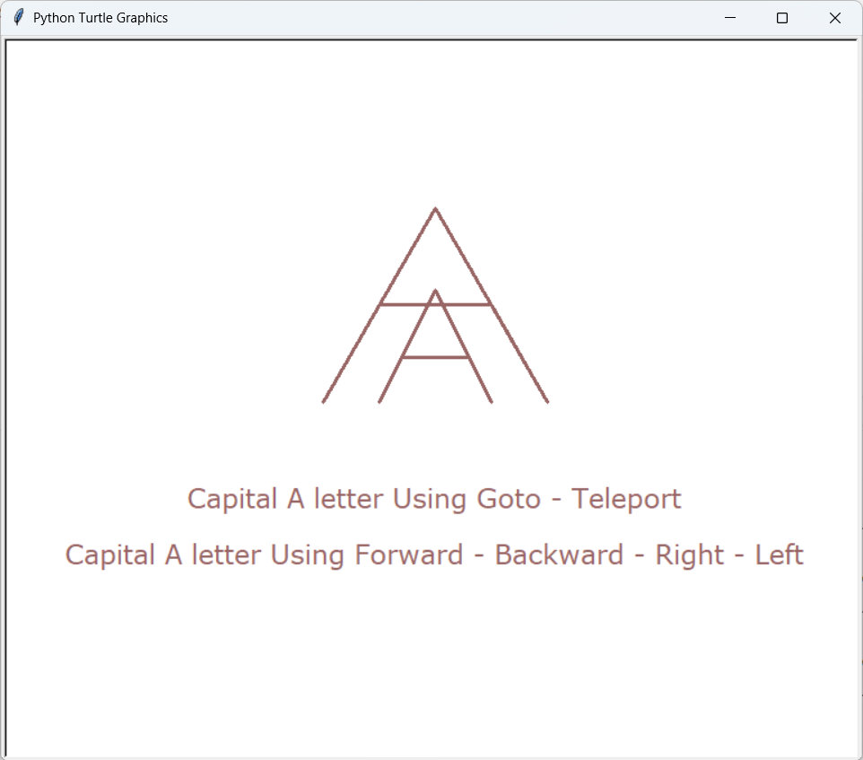

Week 2

draw Letter A

Genius Smart Education | Python Level 1 | 2025-2-4

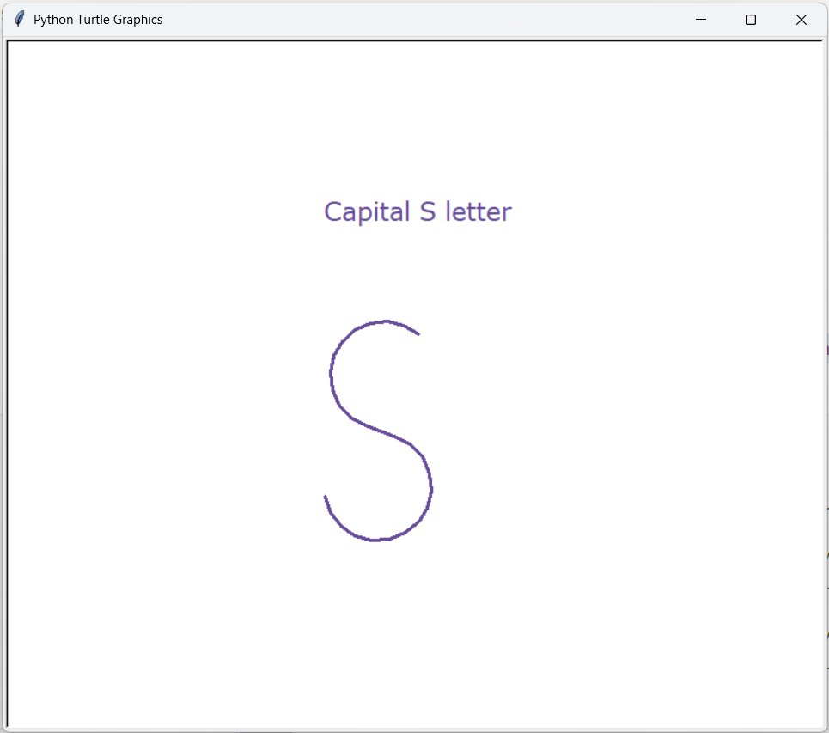

Week 2

draw Your Intial

Genius Smart Education | Python Level 1 | 2025-2-4

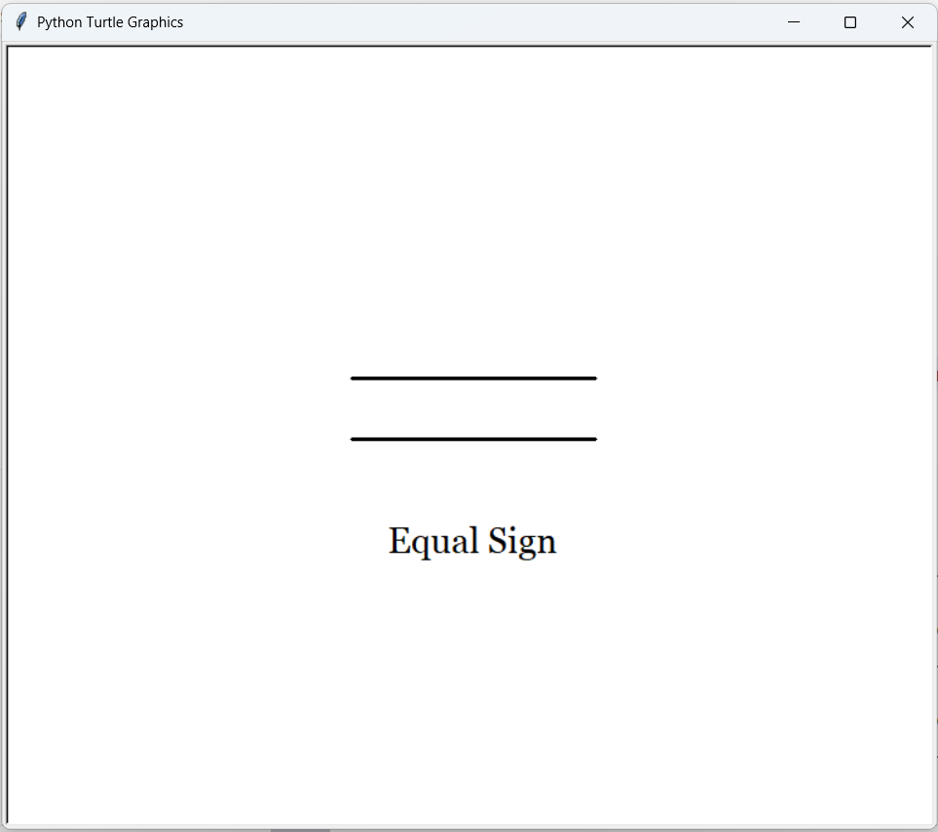

Week 2

draw an Equal Sign

Genius Smart Education | Python Level 1 | 2025-2-4

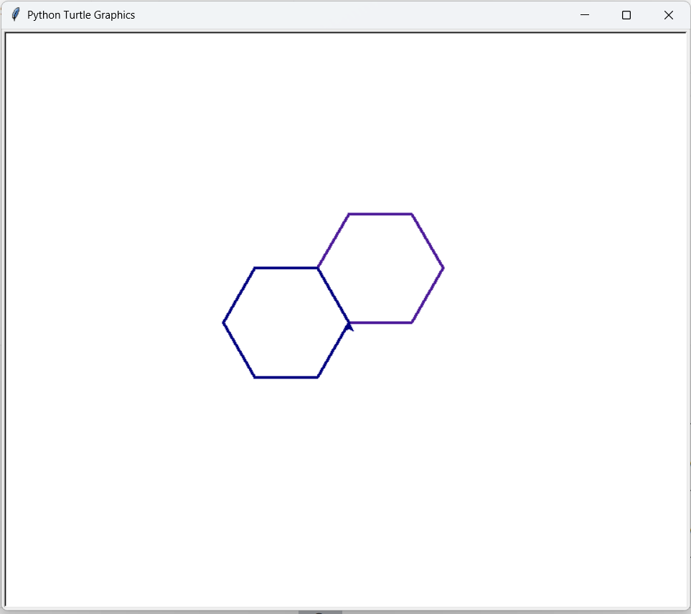

Week 2

draw a Hexagon

Genius Smart Education | Python Level 1 | 2025-2-4

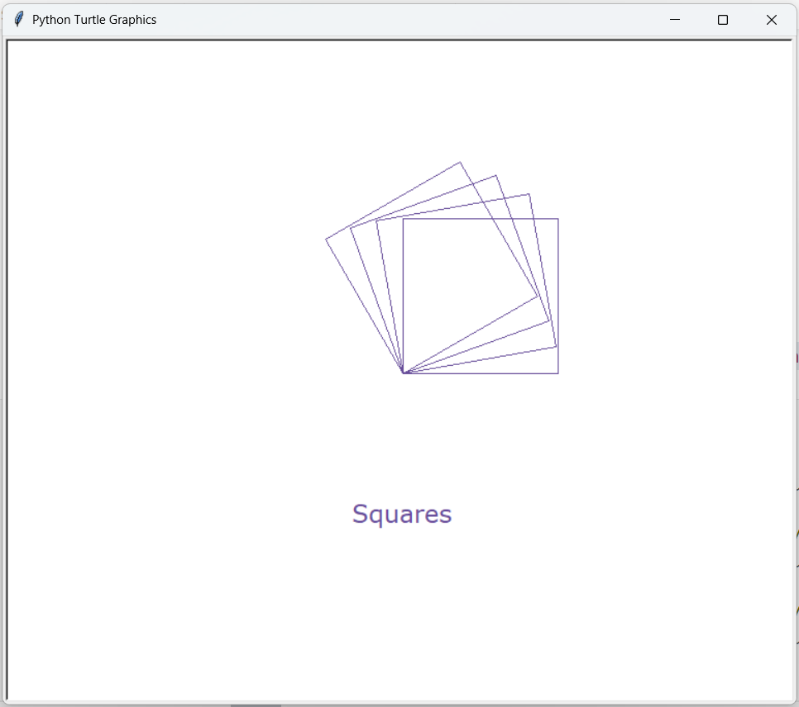

Week 2

draw Squares with different start angle

Genius Smart Education | Python Level 1 | 2025-2-4

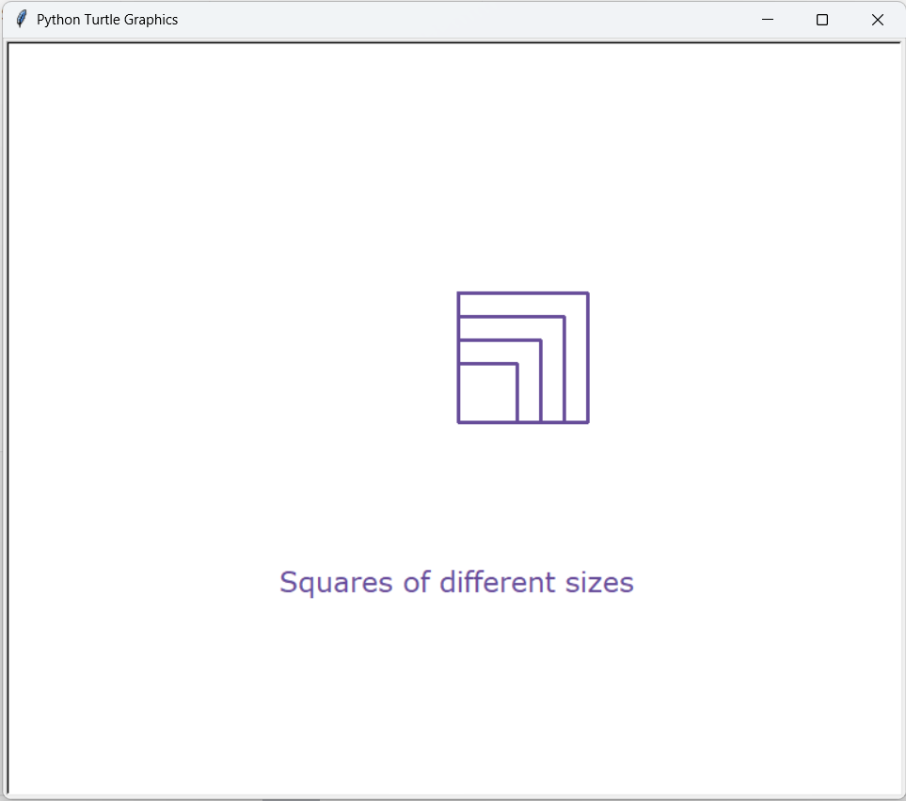

Week 2

draw squares with different sizes

Genius Smart Education | Python Level 1 | 2025-2-4

Week (3) Homework

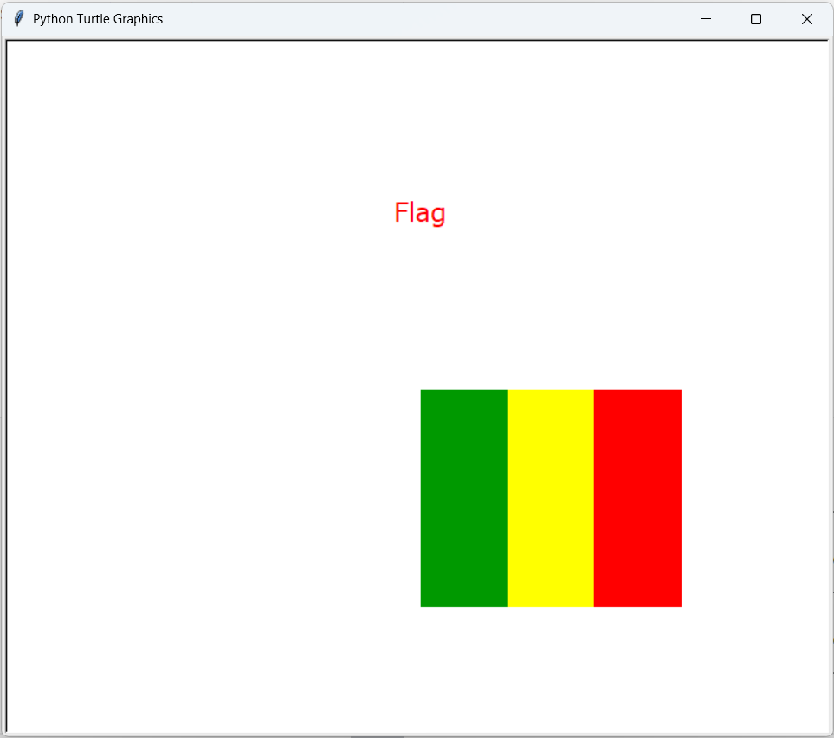

Week 3

Flag

Genius Smart Education | Python Level 1 | 2025-2-4

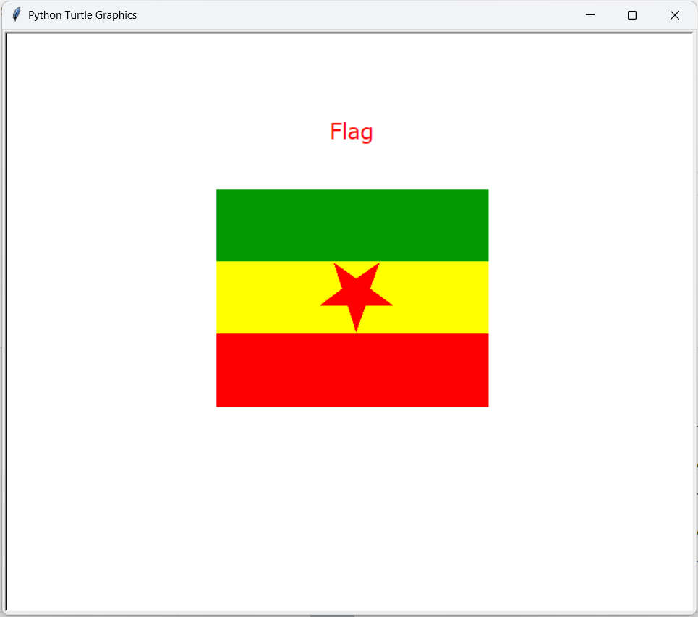

Week 3

Flag With star – star is bonus

Genius Smart Education | Python Level 1 | 2025-2-4

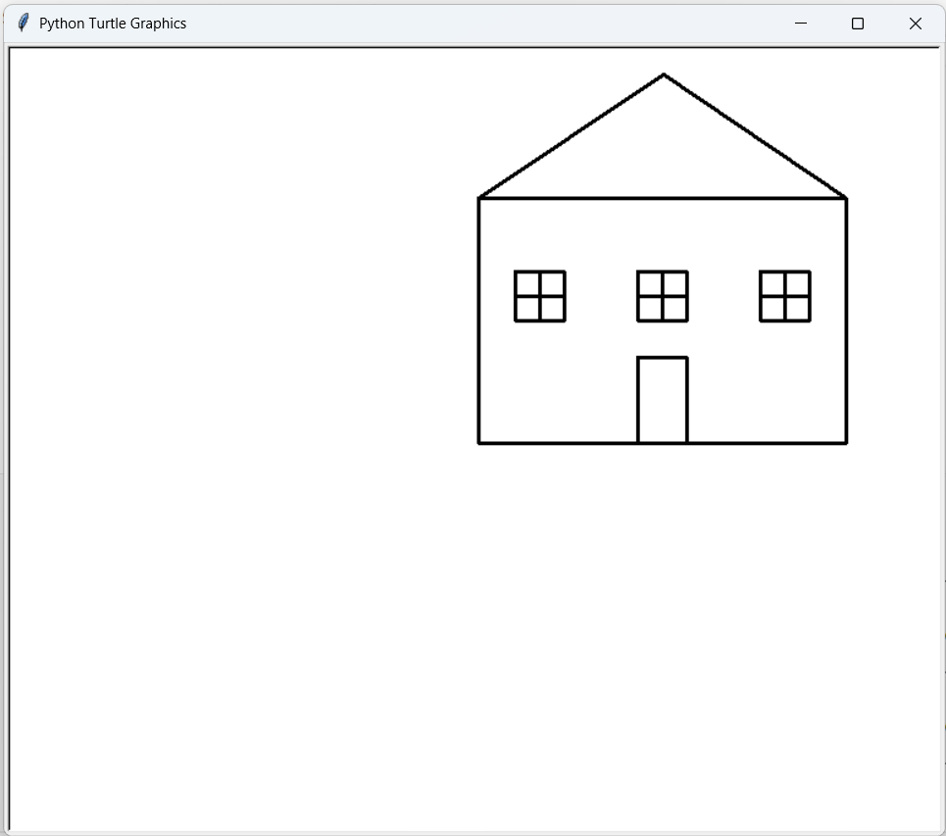

Week 3

HOME

Genius Smart Education | Python Level 1 | 2025-2-4

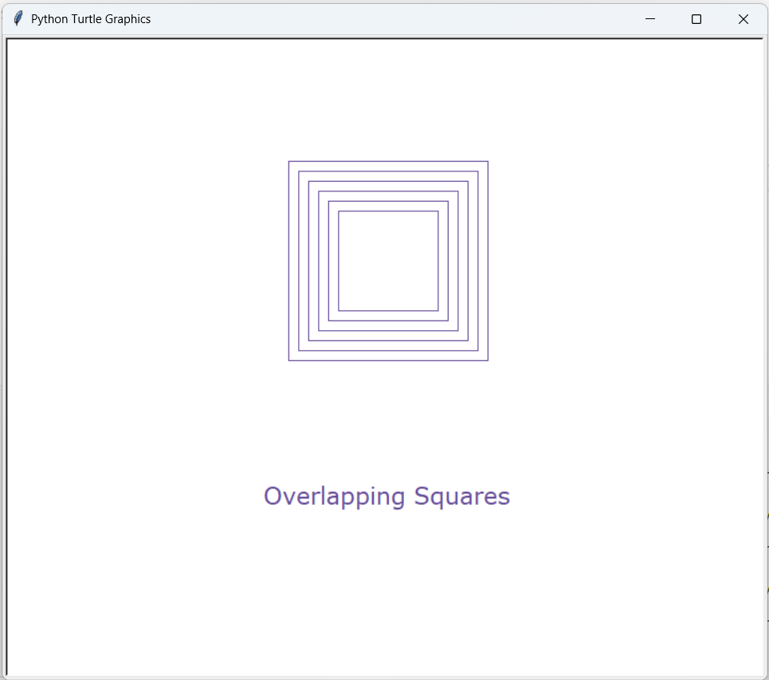

Week 3

Squares

Genius Smart Education | Python Level 1 | 2025-2-4

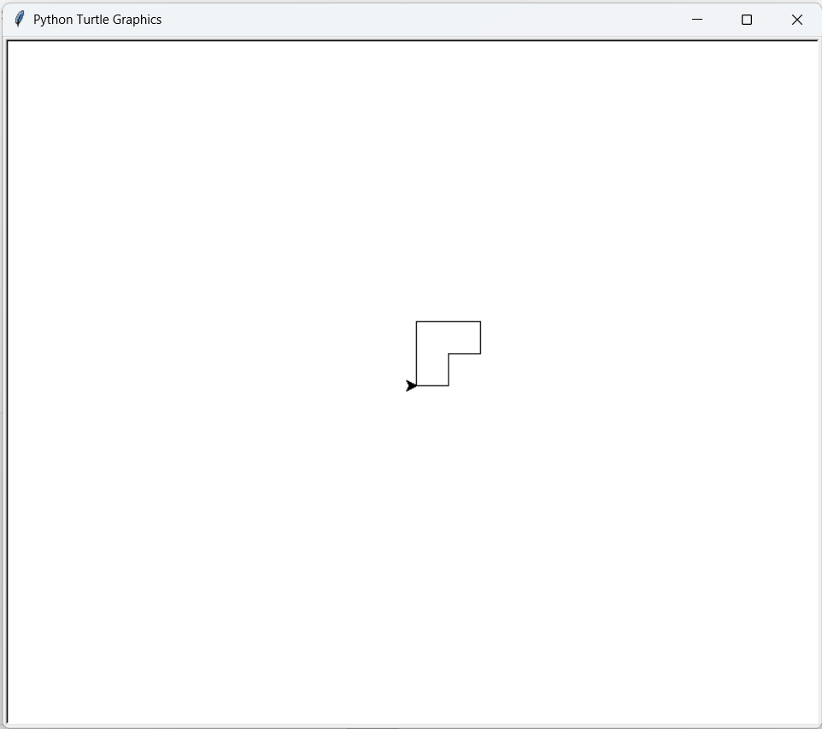

Week 3

USE setx sety only

Genius Smart Education | Python Level 1 | 2025-2-4

Week (4) Homework

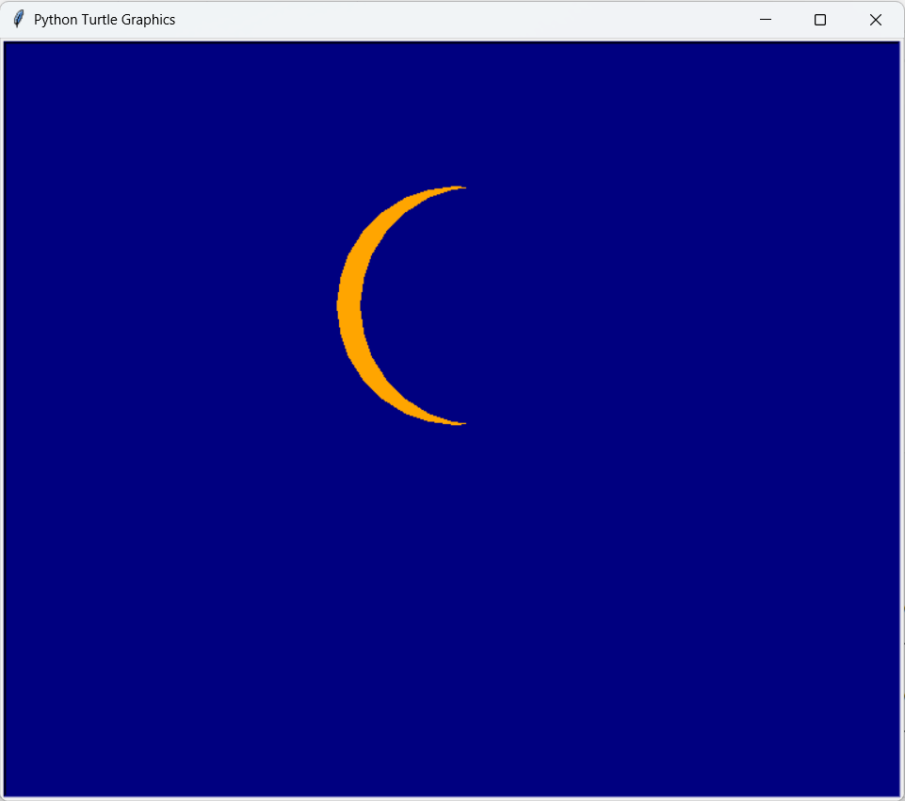

Week 4

MOON

Genius Smart Education | Python Level 1 | 2025-2-4

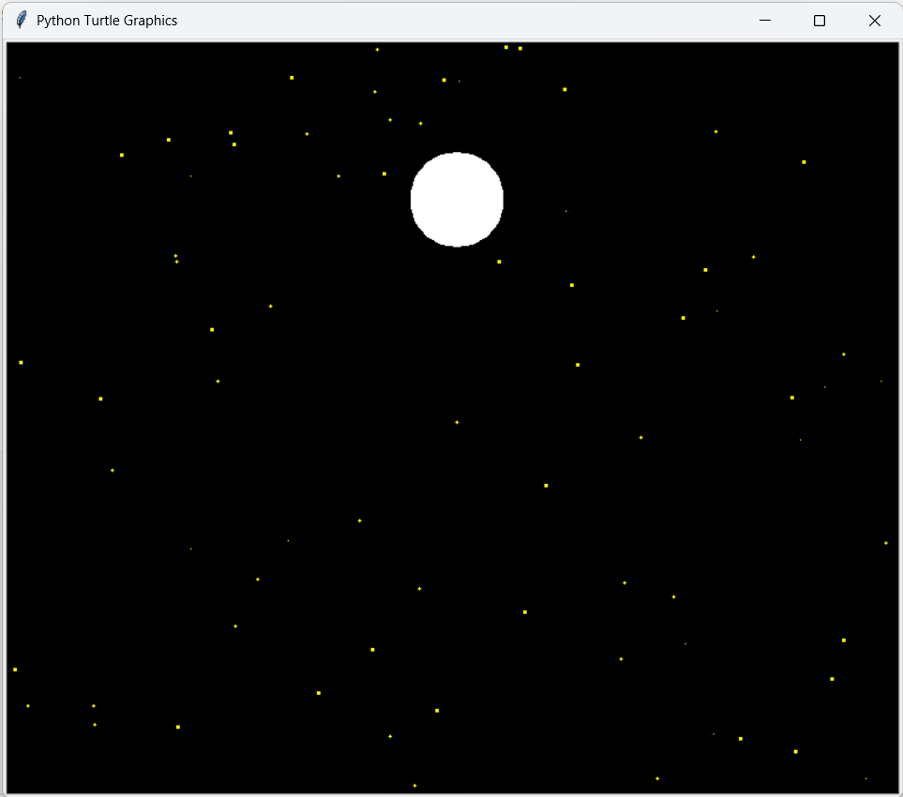

Week 4

MOON SKy

Genius Smart Education | Python Level 1 | 2025-2-4

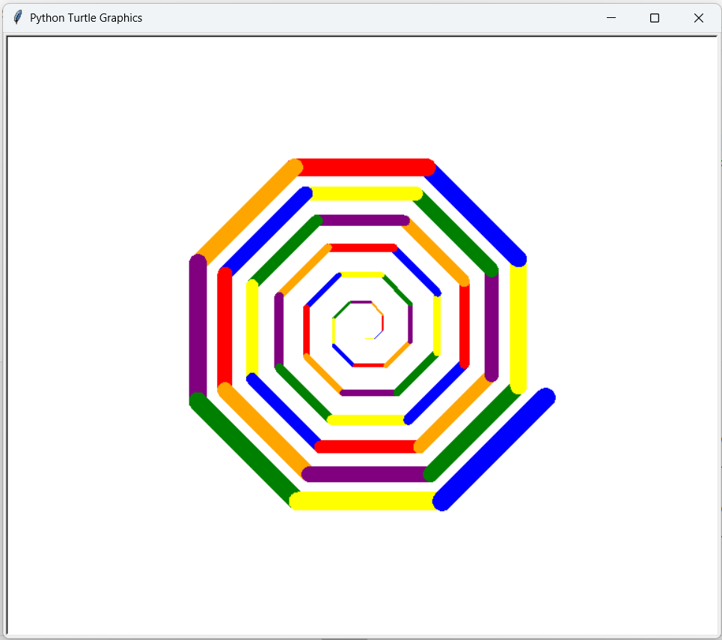

Week 4

spiral

Genius Smart Education | Python Level 1 | 2025-2-4

Week (5) Homework

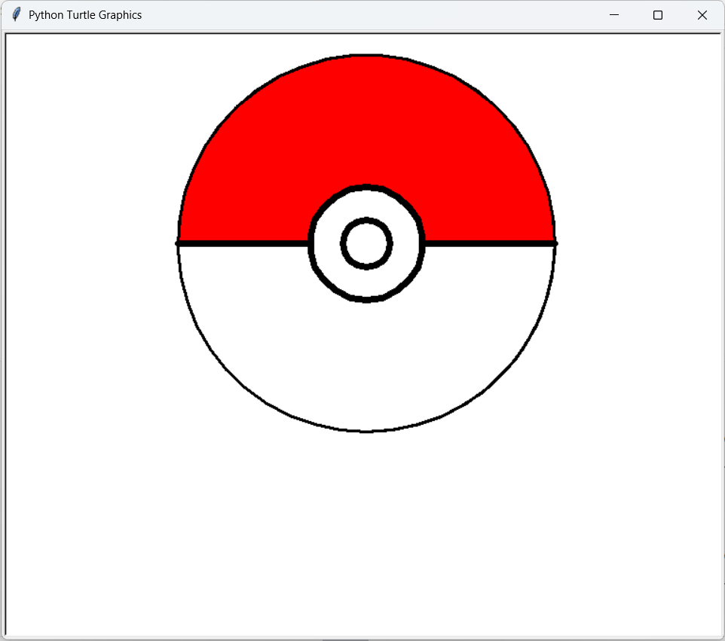

Week 5

Pokemon

Genius Smart Education | Python Level 1 | 2025-2-4

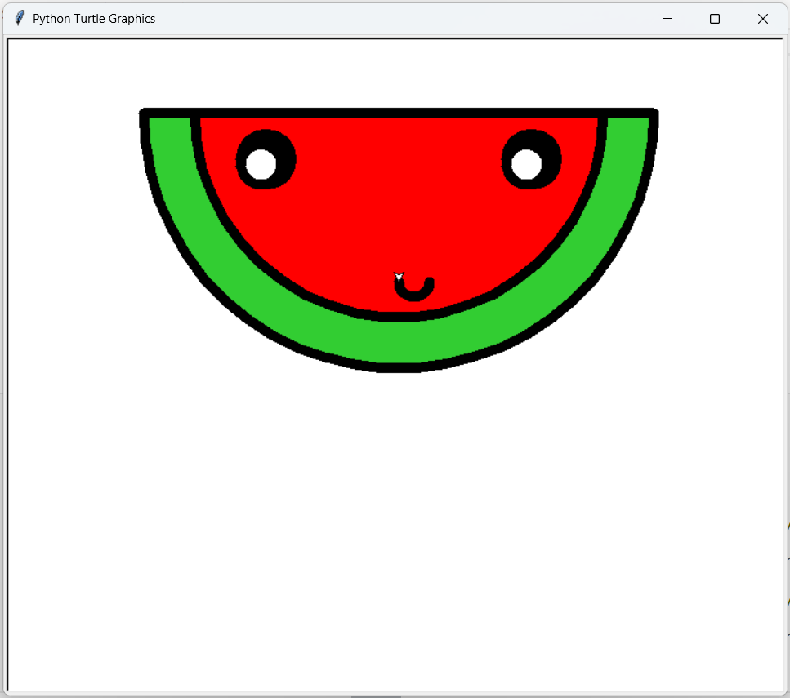

Week 5

watermalon

Genius Smart Education | Python Level 1 | 2025-2-4

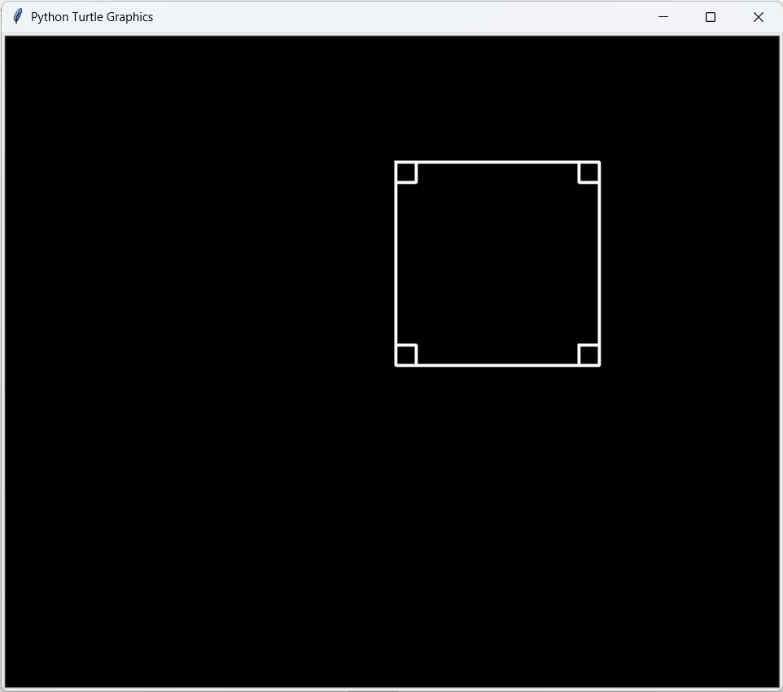

Week 5

sqaure using write method and clear method

Genius Smart Education | Python Level 1 | 2025-2-4

Week (6) Homework

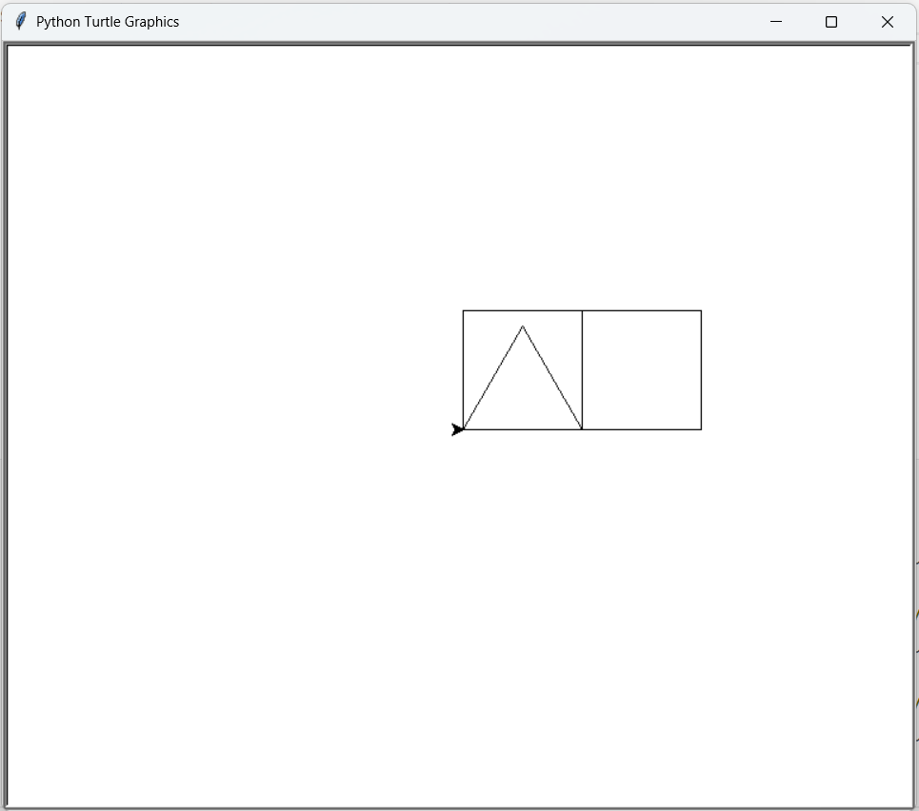

Week 6

Drawer progrm

**using letters:**

**s-> square**

**r -> rectangle**

**t -> Triangle**

**space -> clear**

Genius Smart Education | Python Level 1 | 2025-2-4

Week (7) Homework

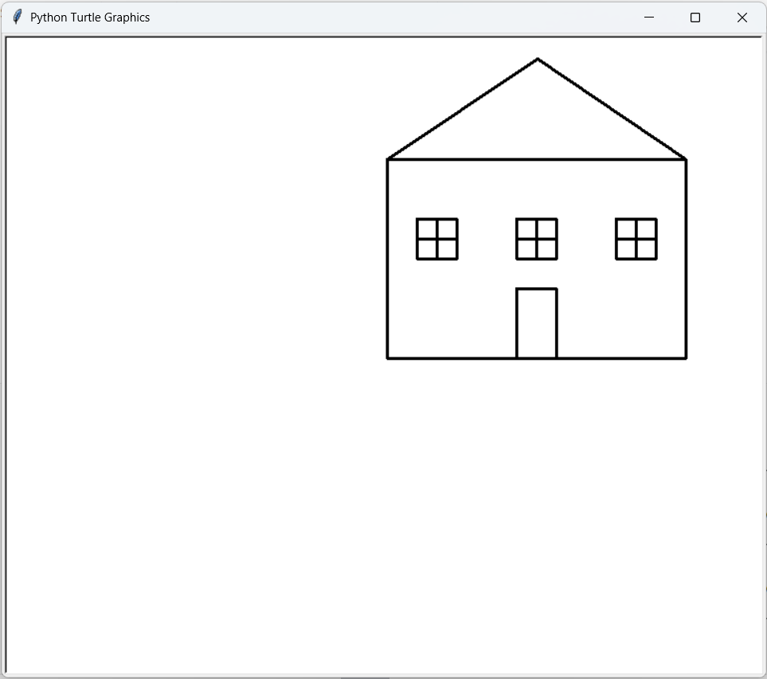

Week 7

**Home using functions**

**def move_to(x, y):**

**def draw_square(x, y, length):**

**def draw_rectangle(x, y, length, width):**

Genius Smart Education | Python Level 1 | 2025-2-4

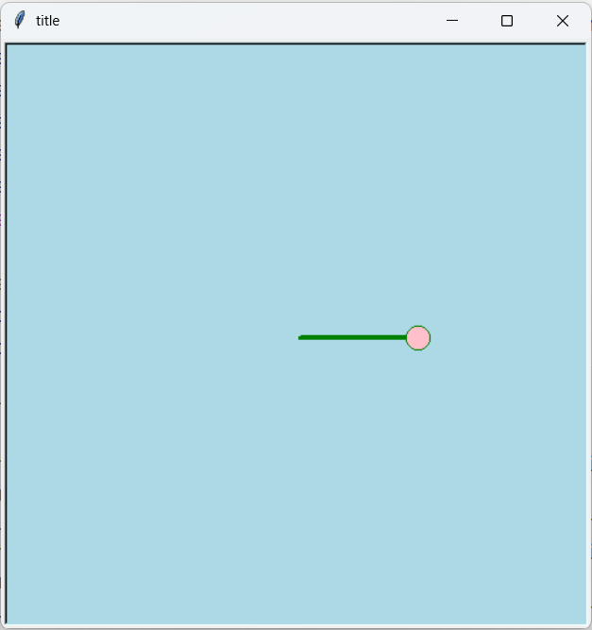

Week 7

**def make_turtle(shape, speed, color, fillcolor, pensize):**

**def make_screen(title, bgcolor, width, height):**

Genius Smart Education | Python Level 1 | 2025-2-4

Week (8) Homework

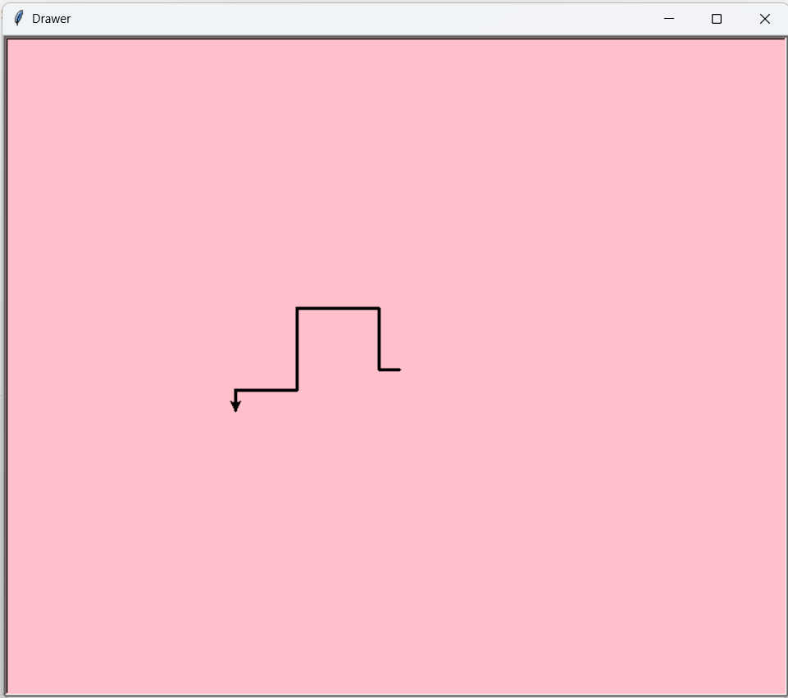

Week 8

### turtle.onkey(right  , 'Right')

### turtle.onkey(left, 'Left' )

### turtle.onkey(up , 'Up'   )

### turtle.onkey(down, 'Down' )

### turtle.onkey(forward   , 'f')

### turtle.onkey(pen.home  , '0')

### turtle.onkey(pen.clear , ' ')

### turtle.onkey(turn_right, '+')

### turtle.onkey(turn_left , '-')

Genius Smart Education | Python Level 1 | 2025-2-4